General Model of Water in State of Israel
As a part of the whole model of consumption - emission of the state of Israel we offer here a general model of the water. We described here the model as a system of consumers and suppliers, while the model explains the relation between them. While building the model we made assumptions that will be suit to the Israeli eco-system :
- All the demand will be provided.
- The amount of the water from nature will be decrease in 25% until 2050.
- The amount of the water for agriculture keeps growing.
- There is no consideration of external events and economic costs.
As we see in the attached figure the source of growing of the water model is the growing population. Each consumer demand different kind of water and in some cases derivative of the use create water to supply.
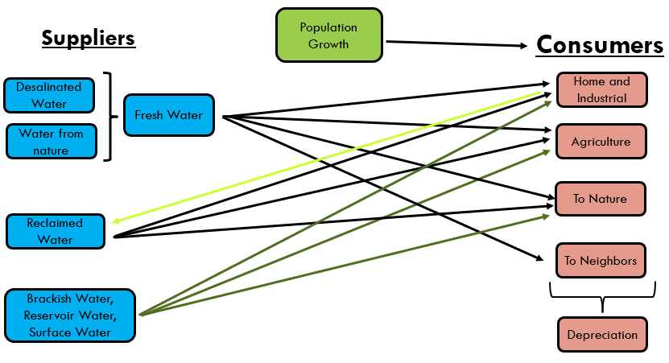
We will detail the calculation methods for each of the factors in the model –
Consumers
Home and industrial
The consumption equation is $H\left(t\right)=h.p.c*P\left(t\right)$ while :
- H - The amount of domestic consumption in million cubic meters
- t – time, year
- h.p.c - Average household consumption per capita in cubic meters
- P - Population size in millions

Agricultural
The consumption equation is $A\left(t\right)=a.p.c*P\left(t\right)$ while :
- A - The amount of agricultural consumption in million cubic meters
- t – time, year
- a.p.c - Average agricultural consumption per capita in cubic meters
- P - Population size in millions

For Nature
There is no orderly outline for releasing water into nature and it depends on excess pumping, amounts of precipitation and spot decisions. Therefore, it is not possible to make a forecast for water for nature.
Based on past data, we decided to use a schematic forecast of the Israel Water Company.

For Neighbors
• Water for neighbors is measured according to the quantities of water supplied to Jordan and the Palestinians, and it constitutes about 7 percent of Israel's total fresh water consumption.
• The supply of water to Jordan is dictated by periodic agreements that are signed, currently 90 million cubic meters are supplied.
• The supply of water to the Palestinians is also determined according to agreements, but there are often deviations from the agreements and a higher quantity than the agreement is provided.
The consumption equation is $F.N\left(t\right)=p.p.c*P.P\left(t\right)+J$ while :
• N.F – the amount of water for the neighbors in million cubic meters
• t – time, year
• p.p.c - average Palestinian consumption per capita supplied by Israel
• P.P - Palestinian population size in millions
• J - the amount of water supplied to Jordan according to an updated agreement.

Suppliers
Water from Nature
• The supply of natural water is expected to decrease in the future due to a consistent decrease in the amount of precipitation, which makes it difficult to fill the water sources from which they draw
• According to a forecast by the Israeli Water Company by 2050 there will be a 5 percent decrease in the amount of precipitation, and this will reduce the volume of refilling in the reservoirs between 20 and 30 percent
• Therefore, we calculate a decrease in the volume of natural water supply proportionally to the refilling and we expect a 25 percent decrease in the use of natural water.

Reclaimed Water
• The percentage of the amount of leachate that reaches reuse is relatively consistent in recent years and stands at about 66 percent of water that is reused. We assume that this number can even increase in the future due to technological improvements.
• Despite this, we decided to calculate the amount of water when 66 percent of the benign water that flows for domestic use is reused as wastewater.

Other Water
• The brackish water is a supplementary water source for the various requirements, where it mainly supports agricultural consumption, but about 20 percent of it is also allocated for domestic consumption. In recent years, the use of brackish water averages 220 million cubic meters per year.
• Reservoir water is used for a variety of uses such as water for agriculture, nature and more. This amount of water varies according to the amount of annual precipitation and therefore cannot be predicted. Here, too, in recent years, the use averages 35 million cubic meters per year.
• Benign surface water from reservoirs that are above ground (lakes for example) and are used as drinking water and stand for a relatively constant amount of 140 million cubic meters per year.
• For brackish water there is no planning to increase the pumping and it is relatively constant, therefore we chose to take the brackish water, benign surface water and reservoir water as a fixed figure which is 400 million cubic meters per year

Desalination Water
The role of desalinated water is to bridge the gap between demand and supply, and this is how the required amounts of desalination are calculated
The equation for forecasting the amount of desalinated water is
$D\left(t\right)=H\left(t\right)+A\left(t\right)+F.N\left(t\right)-N\left(t\right)-S.T$ while :
• D(t) – the amount of desalinated water
• H(t) – domestic consumption of soft water only
• A(t) – agricultural consumption of fresh water only
• F.N(t) – for neighbors
• T.N(t) – water for nature
• N(t) – natural water
• W(t) – Reclaimed water
• S.T – fresh surface water

In conclusion, it can be said that our model is based on a division into suppliers and consumers and is described in the following equation where on the right side of the equation are the consumers and on the left side are the suppliers:
$$D\left(t\right)+N\left(t\right)+W(t)+S.T=H\left(t\right)+A\left(t\right)+F.N\left(t\right)+T.N\left(t\right)$$

